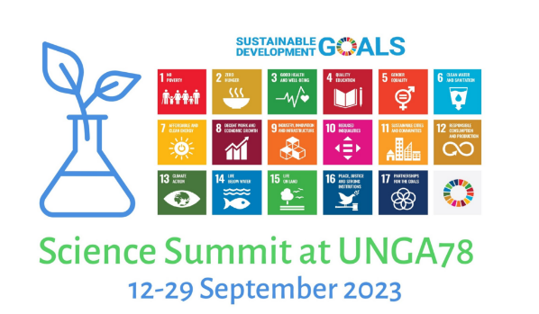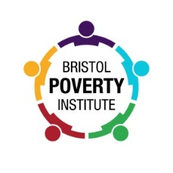

PRESS RELEASE

Advanced Tools for Analyzing Poverty, Climate and Environmental Changes

Session at the Science Summit at UN General Assembly, New York, September 18

The United Nations Sustainable Development Goals (SDGs) aim to guide global social, economic and environmental policies up to 2030. The eradication of poverty, zero hunger, climate action, the preservation of life and biodiversity are all central to the SDG agenda. To achieve these goals, we need to understand how to feed a growing population and guarantee a decent livelihood for everyone without exhausting the planet’s environmental resources. We also need more accurate poverty measures which allow reliable comparisons between countries and over time. We need improved knowledge about how poverty and environmental challenges coincide and interact over time, to better understand how to formulate policies that allow both the eradication of poverty and a sustainable environment. Knowledge is central to meeting these challenges.

On September 18, a session will bring researchers together to present on recent advances in:
- How to improve the large-scale survey measurement of poverty to produce globally comparable measures.
- How to use the advances in satellite-based information to analyze poverty, living conditions and environmental challenges.
- How to combine large-scale survey data and satellite data to better understand causes and consequences of poverty, and environmental challenges facing today’s societies.

This session will help to set a new standard for our ability to inform policy makers about how to balance and combine social and environmental policies to achieve long term and sustainable poverty alleviation.

- Towards globally comparable consensual survey-based measurement of poverty. | David Gordon, Joanna Mack & Hector Najera
- Estimating child poverty using consensual measurement in Iran. | Morteza Nazari
- Recent advances in understanding global flood risk. | Jeffrey Neal, Andrew Smith & Oliver Wing
- Combining geocoded extreme weather-related disaster data with social survey microdata. | David Gordon, Nkechi Owoo & Mary Zhang
- Combining satellite data on deforestation with survey data on poverty. | Hans Ekbrand, Björn Halleröd & Mary Zhang
- Combining deep-learning, satellite technologies and survey data on human development. | Adel Daoud

When: September 18th, 8:00 am to 11:00 am (American Eastern Time)
Where: 633 Third Avenue, 22nd Floor, New York or online via Zoom.
How: Register at https://sciencesummitunga.com/ssunga78/ and find the session in the schedule.
Eradicating Poverty
Professor David Gordon (University of Bristol) said, ”All countries have agreed to try to eradicate child and adult poverty during the 21st Century. If they are successful, this will represent humanity’s greatest achievement. In order to eradicate poverty, policy makers will need both political will and adequate resources but they will also need high quality information about the extent and nature of poverty in order to develop more effective and efficient anti-poverty policies. Good anti-poverty policy requires good measurement to help target resources where they are most needed and to monitor progress. It is unlikely that poverty will be eradicated if it cannot be accurately measured.

“Unfortunately, there are currently no poverty measures which can be used in all countries. This new research shows how meaningful and truly comparable poverty measurements in all countries could be produced in the future.”

Protecting the Environment
Professor Björn Halleröd (University of Gothenburg) said, “The greatest challenge of the 21st Century is how to ensure that global living standards improve while also protecting and improving the environment. Poverty and inequality need to fall and environment protection and biodiversity need to increase if we are to live on a better planet than the one we inherited from our parents. By combining environmental information from satellites with high quality social survey data, we can understand the complex relationships between poverty and deforestation on a global scale in order to formulate more effective policies.”

Protecting Vulnerable People from Climate Change
Dr Nkechi Owoo (University of Ghana) said, “Climate change will intensify the hydrological cycle – more frequent and intense storms, floods, landslides and droughts. It will also cause the oceans to warm, expand and acidify. Changes may occur to both ‘typical’ weather patterns and ocean current circulation. Mitigation measures need to be targeted to protect vulnerable people living in exposed areas. Our new research combines social survey and environment data in African countries to identify where the people most vulnerable and exposed to extreme weather events live.”

Dr Andrew Smith (Fathom) said, "In a warming world, global flood risks will invariably increase and the poorest are often amongst the most vulnerable to flood hazards. It’s great to see this topic on the agenda for the Science Summit. We’re looking forward to meeting with industry experts from around the globe to discuss how new research can provide policy makers with the information they need to help mitigate and manage the potentially disastrous impact of flooding."

Improving Children’s Lives
Enrique Delamonica (UNICEF Senior Adviser Statistics and Monitoring of Child Poverty and Gender Equality) said, “Some of the world’s leading poverty, environment and climate researchers have gathered in New York to share their recent scientific advances to inform global policy makers. UNICEF aims to continue to be at the forefront of using the best scientific knowledge to help improve the lives of children and their families. We are delighted to collaborate with these scholars from universities in Africa, Europe, and Latin America and to host this important session at the United Nations General Assembly Science Summit.”

-ENDS-
Notes to the Editor:
The United Nations Science Summit Session will take place at UNICEF, 633 Third Avenue, 22nd Floor, New York on September 18th, 2023.

Interviews can be arranged in advance via:
- Lars-Olof Karlsson, Communications Officer, University of Gothenburg
+46 31–786 4841, +46 76–618 4841, lars-olof.karlsson@gu.se
- Victoria Tagg, Media and PR Manager (Research), University of Bristol,
mobile: +44 (0)7973 681921, email: victoria.tagg@bristol.ac.uk
- Jessica Roberts, PR Manager, Fathom,
+44 117 318 2421, email: j.roberts@fathom.global

Further information
The Bristol Poverty Institute is dedicated to multi-disciplinary research on poverty in both the industrialized and developing world. The Institute has been established by the University of Bristol in response to the United Nations call for Universities to play their part in helping to deliver the Sustainable Development Goals.

